

**The University of Azad Jammu and Kashmir,**

**Muzaffarabad**

|  |  |
| --- | --- |
| Name | Kamal Ali Akmal  Jawahir Ali  Raja Afzaal Ajmal  Syed Ahmed Gillani |
| Group No | 06 |
| Session | 2024-2028 |
| Instructor | Engr. Sidra Rafique |
| Subject | Computer Architecture & Logic Design |
| Project Topic | Fire Alarm System |

**Lab Report: Fire Alarm System**

**Objective**

The objective of this experiment was to design and implement a basic **fire alarm system** using simple electronic components. The system is intended to detect smoke or fire and immediately alert through a buzzer.

**Apparatus / Components Used**

* **Battery (DC 9V / 12V)** – to provide power supply.
* **Breadboard** – for building the circuit without soldering.
* **IR Sensor** – to detect fire or flame by sensing infrared radiation.
* **Smoke Detector Sensor (MQ-2/MQ-135)** – to detect smoke in the environment.
* **Buzzer** – for audio alarm output.
* **Switch** – to turn the system ON/OFF.
* **Connecting Wires** – to establish connections between components.

**Circuit Diagram**

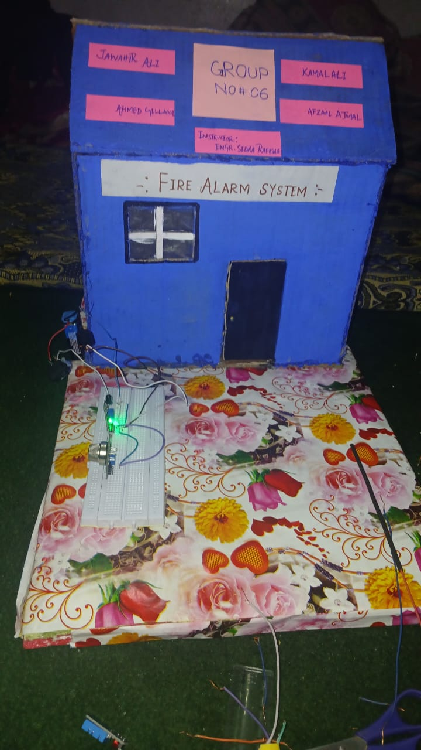

**Theory**

A fire alarm system is designed to sense the presence of **fire indicators** (smoke, gas, or infrared light from flames). In this project:

* The **IR sensor** detects the heat/flame by sensing infrared radiation.
* The **smoke detector** senses the concentration of smoke particles in the air.
* If either sensor detects abnormal conditions, the circuit is triggered.
* The **buzzer** produces a loud sound to alert nearby people.
* The **switch** is used as a control to turn the system ON or OFF.

**Procedure**

1. Place all components on the **breadboard**.
2. Connect the **battery** to the power rails of the breadboard.
3. Connect the **switch** in series with the battery to control power.
4. Attach the **IR sensor** and **smoke detector** outputs to the input pins of the buzzer circuit.
5. Ensure the sensors share a **common ground** with the battery.
6. Connect the **buzzer** to the output such that it receives current when a sensor detects fire/smoke.
7. Connect all parts with **jumper wires** carefully.
8. Power ON the circuit using the switch.
9. Test the system by bringing smoke (e.g., from a matchstick) near the sensor and/or flame near the IR sensor.

**Observations**

* When no fire or smoke was present, the buzzer remained **OFF**.
* On detecting smoke, the smoke sensor output triggered the buzzer.
* On sensing flame/heat (infrared radiation), the IR sensor activated the buzzer.
* The system responded immediately and produced a loud alarm.

**Result**

A **working fire alarm system** was successfully built and tested using a battery, IR sensor, smoke detector, switch, buzzer, and breadboard connections. The buzzer activated when smoke or fire was detected, proving the system can provide an early warning in case of fire hazards.

**Applications**

* Home and office fire alarm systems.
* Industrial safety monitoring.
* Laboratories and storage areas with flammable materials.

**Conclusion**

The experiment demonstrated the successful design of a low-cost and effective **fire alarm system**. Using simple electronic components, the system was able to reliably detect fire or smoke and produce an alarm, showing the importance of electronics in safety applications.